Gravity - 04
CLASS 09 - SCIENCE

 | Section A
1 | Assertion (A): The value of the acceleration due to gravity g on earth depends upon the average density of the earth. Reason (R): It is the radius of the earth which determines the value of the g.  a) Both A and R are true and R is the correct explanation of A.  b) Both A and R are true but R is not the correct explanation of A.  c) A is true but R is false.  d) A is false but R is true. | [1]
2 | Assertion (A): An object floats if it displaces an amount of liquid whose weight is greater than the actual weight of the object. Reason (R): During floatation an object experiences no net force in the downward direction  a) Both A and R are true and R is the correct explanation of A.  b) Both A and R are true but R is not the correct explanation of A.  c) A is true but R is false.  d) A is false but R is true. | [1]
3 | Assertion (A): It is the gravitational force exerted by the sun and the moon on the sea water that causes to the formation of tides in the sea. Reason (R): Gravitational force of attraction is a strong force.  a) Both A and R are true and R is the correct explanation of A.  b) Both A and R are true but R is not the correct explanation of A.  c) A is true but R is false.  d) A is false but R is true. | [1]
4 | Assertion (A): Mass is a scalar quantity. Reason (R): It has a magnitude as well as direction.  a) Both A and R are true and R is the correct explanation of A.  b) Both A and R are true but R is not the correct explanation of A.  c) A is true but R is false.  d) A is false but R is true. | [1]
5 | Assertion (A): A school bag has wide straps. Reason (R): The weight of the books may spread over a large area of the child’s shoulder.  a) Both A and R are true and R is the correct explanation of A.  b) Both A and R are true but R is not the correct explanation of A.  c) A is true but R is false.  d) A is false but R is true. | [1]
6 | Assertion (A): The motion of the moon around the earth is due to the centripetal force. Reason (R): The centripetal force causes acceleration and keeps the body moving along the circular path.  a) Both A and R are true and R is the correct explanation of A.  b) Both A and R are true but R is not the correct explanation of A.  c) A is true but R is false.  d) A is false but R is true. | [1]
7 | Assertion (A): Weight of an object is the force with which a body attracted towards the earth. Reason (R): Its direction is vertically upwards.  a) Both A and R are true and R is the correct explanation of A.  b) Both A and R are true but R is not the correct explanation of A.  c) A is true but R is false.  d) A is false but R is true. | [1]
8 | Assertion (A): The falling of a body from a height towards the earth under its gravitational force is called free fall. Reason (R): Whenever objects fall towards the earth under gravitational force,we say that the objects are in free fall.  a) Both A and R are true and R is the correct explanation of A.  b) Both A and R are true but R is not the correct explanation of A.  c) A is true but R is false.  d) A is false but R is true. | [1]
9 | Assertion (A): The weight of a body on earth is equal to the force with which the body is attracted towards the earth. Reason (R): The weight of a body is independent of the mass of the body.  a) Both A and R are true and R is the correct explanation of A.  b) Both A and R are true but R is not the correct explanation of A.  c) A is true but R is false.  d) A is false but R is true. | [1]
10 | Assertion (A): The value of acceleration due to gravity changes with the height, depth and shape of the earth. Reason (R): Acceleration due to gravity is zero at the centre of the earth.  a) Both A and R are true and R is the correct explanation of A.  b) Both A and R are true but R is not the correct explanation of A.  c) A is true but R is false.  d) A is false but R is true. | [1]
11 | Assertion (A): A sheet of paper falls slower, than one that is crumpled into a ball. Reason (R): Sheet of paper has lesser weight than that is crumpled into a ball.  a) Both A and R are true and R is the correct explanation of A.  b) Both A and R are true but R is not the correct explanation of A.  c) A is true but R is false.  d) A is false but R is true. | [1]
12 | Assertion (A): During a journey from the earth to the moon and back, maximum fuel is spent to overcome the earth’s gravity at take off. Reason (R): Earth’s mass is much greater than that of the moon.  a) Both A and R are true and R is the correct explanation of A.  b) Both A and R are true but R is not the correct explanation of A.  c) A is true but R is false.  d) A is false but R is true. | [1]
13 | Assertion (A): According to the universal law of gravitation, every object in the universe attracts every other object with some force. Reason (R): The direction of force is along the line joining the centres of the two bodies.  a) Both A and R are true and R is the correct explanation of A.  b) Both A and R are true but R is not the correct explanation of A.  c) A is true but R is false.  d) A is false but R is true. | [1]
14 | Assertion (A): Kepler’s second law of planetary motion is also known as Kepler’s law of areas. Reason (R): The line joining the planet and the sun sweeps equal areas in equal intervals of time.  a) Both A and R are true and R is the correct explanation of A.  b) Both A and R are true but R is not the correct explanation of A.  c) A is true but R is false.  d) A is false but R is true. | [1]
15 | Assertion (A): When the distance between two bodies is doubled and also the mass of each body is doubled, then the gravitational force between them remains the same. Reason (R): According to Newton’s law of gravitation, a product of force is directly proportional to the product mass of bodies and inversely proportional to the square of the distance between them.  a) Both A and R are true and R is the correct explanation of A.  b) Both A and R are true but R is not the correct explanation of A.  c) A is true but R is false.  d) A is false but R is true. | [1]
16 | Assertion (A): Universal gravitational constant G is a scalar quantity. Reason (R): The value of G is same throughout the universe.  a) Both A and R are true and R is the correct explanation of A.  b) Both A and R are true but R is not the correct explanation of A.  c) A is true but R is false.  d) A is false but R is true. | [1]
17 | Assertion (A): A spring balance that shows the weight of a body to be 6 N on earth will show a weight of only 1 N when taken to the moon. Reason (R): The weight of an object on the moon will be about one - sixth of what is on the earth.  a) Both A and R are true and R is the correct explanation of A.  b) Both A and R are true but R is not the correct explanation of A.  c) A is true but R is false.  d) A is false but R is true. | [1]
18 | Assertion (A): Any two objects in the universe attract each other by a force called gravitation force. Reason (R): The force of gravitation exerted by the earth is called gravity.  a) Both A and R are true and R is the correct explanation of A.  b) Both A and R are true but R is not the correct explanation of A.  c) A is true but R is false.  d) A is false but R is true. | [1]
19 | Assertion (A): When the orbital radius of a planet is made 4 times, its time period increases by 8 times. Reason (R): Greater the height above the earth’s surface, greater is the time period of revolution.  a) Both A and R are true and R is the correct explanation of A.  b) Both A and R are true but R is not the correct explanation of A.  c) A is true but R is false.  d) A is false but R is true. | [1]
20 | Assertion (A): The acceleration experienced by an object during free fall is dependent on its mass. Reason (R): All objects hollow or solid, big or small, should fall at the same rate.  a) Both A and R are true and R is the correct explanation of A.  b) Both A and R are true but R is not the correct explanation of A.  c) A is true but R is false.  d) A is false but R is true. | [1]
21 | Assertion (A): An object floats on the surface of a liquid in a beaker. The whole system is allowed to fall freely under gravity. The upthrust on the object due to the liquid is equal to the weight of the liquid displaced. Reason (R): Archimedes’ principle states that the upthrust on an object due to a fluid is equal to the weight of the fluid displaced.  a) Both A and R are true and R is the correct explanation of A.  b) Both A and R are true but R is not the correct explanation of A.  c) A is true but R is false.  d) A is false but R is true. | [1]
22 | Assertion (A): The force of attraction of the earth on an object is known as the weight of the object. Reason (R): The SI unit of weight is the joule (J).  a) Both A and R are true and R is the correct explanation of A.  b) Both A and R are true but R is not the correct explanation of A.  c) A is true but R is false.  d) A is false but R is true. | [1]
23 | Assertion (A): The weight of an object on the moon is less than that on the earth. Reason (R): The mass and radius of the moon are less than that of earth.  a) Both A and R are true and R is the correct explanation of A.  b) Both A and R are true but R is not the correct explanation of A.  c) A is true but R is false.  d) A is false but R is true. | [1]
24 | Assertion (A): At the centre of earth, a body has a centre of mass but no centre of gravity. Reason (R): Acceleration due to gravity at the centre of the earth is zero.  a) Both A and R are true and R is the correct explanation of A.  b) Both A and R are true but R is not the correct explanation of A.  c) A is true but R is false.  d) A is false but R is true. | [1]
25 | Assertion (A): When a piece of cork is held below the surface of the water by applying the force of our thumb and then released, the cork immediately rises to the surface. Reason (R): The upward force is exerted by water on the cork which pushes it to the surface.  a) Both A and R are true and R is the correct explanation of A.  b) Both A and R are true but R is not the correct explanation of A.  c) A is true but R is false.  d) A is false but R is true. | [1]
26 | Assertion (A): If we drop a stone and a sheet of paper from a balcony of first floor, then stone will reach the ground first. Reason (R): The resistance due to air depends on velocity only.  a) Both A and R are true and R is the correct explanation of A.  b) Both A and R are true but R is not the correct explanation of A.  c) A is true but R is false.  d) A is false but R is true. | [1]
 | Section B
27 | State True or False:  - Duringfreefall, thereisnochangeinthedirectionofmotionoftheobject,butthemagnitudeofthe velocity of the falling object changes.  - The falling of a body from a height towards the earth under its gravitational force is called free fall.  - The centripetal force is provided by the force of attraction of the earth.  - Whenanobjectispartiallyorwhollyimmersedinafluid,anupwardforceactson it,which is called upthrust or buoyant force.  - According to Newton, every object in this universe attracts every other object with a certain force, called gravitational force.  - A fluid exerts pressure in all directions, even upwards.  - The gravitational force holds the Solar System together.  - According to Pascal’s law, the pressure exerted in any confined mass of fluid is transmitted uniformly in all directions.  - Archimedes’ Principle states that the buoyant force acting on an object is equal to the weight ofthe fluid displaced by that object.  - Universal Law of Gravitation was given by Sir Isaac Newton.  - Kepler’s First Law states that the planets move around the Sun in elliptical orbits, with the Sun at one of the two foci of the elliptical orbit.  - The earth attracts or pulls all the objects towards the center.  - An object with density morethan the liquid floats on the liquid.  - Thevalueof g isminimumonthesurfaceofthe earth.  - Kepler’s FirstLaw states that the cube of the mean distance ‘r’ of a planet from the Sun is directly proportional to the square of its orbital period ’T’.  - When an object is immersed fully or partially in a fluid, it experiences an upward force which is equal to the weight of the fluid displaced by it.  - The magnitude of the buoyant force depends on the volume of the object immersed in the liquid and the density of the liquid. | [17]
 | Section C
28 | Fill in the blanks:  - The weight of an object on the moon will be about ________ of what is on the earth.  - When an object is partially or wholly immersed in a fluid, an upward force acts on it, which is called ________.  - The force with which the earth pulls the objects towards it is called________.  - The value of gis maximum on the surface of the ________.  - Whenever an object falls towards the earth, ________ is involved.  - If the buoyant force exerted by the liquid is equal to the weight of the object, the object will ________ in the liquid.  - An object with a density less than the liquid ________ on the liquid.  - The motion of the moon around the earth is due to the ________ force.  - The ________ of the body is the quantity of matter contained in it.  - ________ is the force acting perpendicularly on an object.  - SI unit of weight is ________.  - The ________ force holds the Solar System together.  - The ________ of the body is the force with which it is attracted towards the centre of the earth.  - According to the second law of motion, ________ is the product of mass and acceleration.  - ________ is the force acting perpendicularly on a unit area of the object.  - The acceleration experienced by an object during free fall is independent of its ________. | [16]
 | Section D
29 | For performing an experiment to verify Archimedes principle, a student used a spring balance with a zero error of 4 g wt. He used to measure the weight of a solid metallic block as shown in the figure below. The solid metallic block was then lowered in water contained in an overflowing jar and the water displaced by this block was collected in graduated or measuring cylinder as shown in figure. 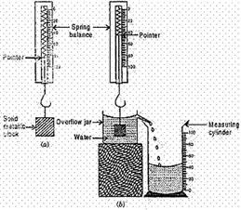  The apparent loss in weight of the solid metallic block is :  a) 38 g wt  b) 35 g wt  c) 40 g wt  d) 30 g wt | [1]
30 | Three students A, B and C determined the volume of a solid by immersing it in water in the overflow cans are set up as shown. The result obtained will be wrong for : 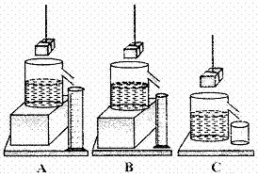  a) Student A  b) All of these  c) Student B  d) Student C | [1]
31 | The level of water in a measuring cylinder before and after a solid of 8 g mass is fully immersed into it as shown.The density of the given solid is: 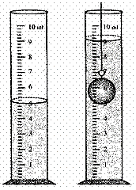  a) 4 g/cm$​^{3}$  b) 3 g/cm$​^{3}$  c) 2 g/cm$​^{3}$  d) 5 g/cm$​^{3}$ | [1]
32 | Three students used three different containers (A) (B) and (C) of different shapes, for finding the loss in weight of solid when dipped in water. On dipping a solid sphere in these containers they would observe that the loss in weight is: 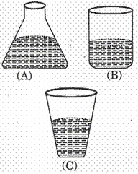  a) Minimum in  [  A  ]  b) Maximum in  [  A  ]  c) Maximum in  [  B  ]  d) Same in all | [1]
33 | The water level in a measuring cylinder, before and after immersing a metal cube in it, is shown in the figure. The volume of the metal cube is: 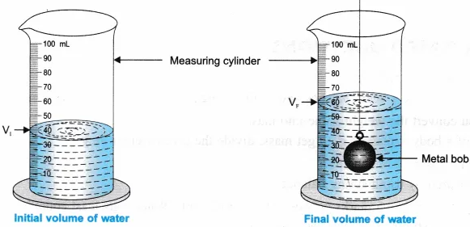  a) 18 cm$​^{3}$  b) 24 cm$​^{3}$  c) 20 cm$​^{3}$  d) 22 cm$​^{3}$ | [1]
34 | In the following figure the zero error is: 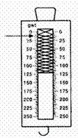  a) 5 gwt  b) – 5 gwt  c) 2 gwt  d) – 2 gwt | [1]
35 | Four students A, B, C and D while performing an experiment on establishing the relation between the loss of weight of small solid when fully immersed in tap water, and the weight of water displaced by it, used four different shapes of overflow cans containing water as shown :The arrangement, that would given correct results is that of student: 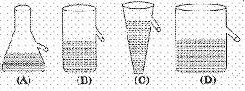  a) A  b) D  c) B  d) C | [1]
36 | In the experiment to establish the relation between loss in weight of an immersed solid with the weight of water displaced by it, the upthrust experience by the object in tap water and in salty water are U$​_{w}$ and U $​_{s}$ respectively, then :  a) U$​_{w}$ < U $​_{s}$  b) U$​_{w}$ > U $​_{s}$  c) U$​_{w}$ = U $​_{s}$  d) U$​_{s}$ = 2U $​_{w}$ | [1]
37 | The position of the water level, in a measuring cylinder, before and after immersing a solid in it, are as shown in the figure given below. The volume of the given solid (in cm$​^{3}$ ) is : 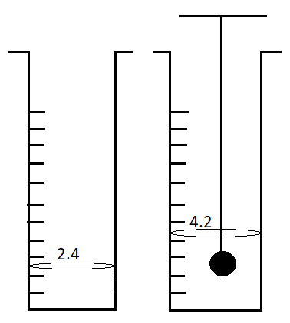  a) 2.2  b) | [1]
38 | The least count of the spring balance shown in the diagram is: 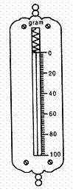  a) 1 g  b) 2 g  c) 0.5 g  d) 5 g | [1]
 | Section E
39 | Statement A: A person will weight more in Ooty than in Delhi. Statement B: Mass is measured by pan balance and weight is measured by spring balance. Which of the two statements is true?  a) Both A and B  b) Neither A nor B  c) Statement B  d) Statement A | [1]
40 | Statement A: Polar radius is 6357km and the equatorial radius is 6378km. Statement B: At a given place the weight of an object is equal to the mass of the object. Which of the two statements is true?  a) statement A and B both  b) statement B  c) neither statement A norstatement B  d) statement A | [1]
41 | Statement A: The Earth attracts the moon with a force greater than the force with which the moon attracts the Earth. Statement B: The mass and weight of a body become 0 at the center of the Earth. Which of the two statements is true?  a) neither statement A nor B.  b) statement B  c) statement A  d) both the statements A and B | [1]
42 | Statement A: Mass of a body is a fundamental property. Statement B: Weight is a fundamental property. Which of the two statements is true?  a) Statement A  b) Neither A nor B  c) Both A and B  d) Statement B | [1]
43 | Statement A: When an object is thrown up then its speed at any position while going up is the same as the speed while coming down. Statement B: A can’t have zero weight. Which of the two statements is true?  a) Both A and B  b) Statement A  c) Neither A or B  d) Statement B | [1]
44 | Which of the two statements is true? Statement A: The force of gravitation may be attractive or repulsive. Statement B: Inverse - square law means $Fα\frac{1}{r^{2}}$ .  a) Statement B  b) Statement A  c) Neither statementAnor B  d) Both statement Aand B | [1]

